Project Specification Documentation

Advance Web Engineering (AWE)



Name: Dinesh Bahadur Ayer

Student Id: 77356697

Project Name: Grocery

Project Type: E-commerce Web Site

**Business Case**

The business case for designing an eCommerce grocery website with Laravel on the backend and React on the frontend is around providing a strong, scalable, and user-friendly platform that is adapted to the changing demands of modern customers. Laravel, known for its simple syntax and extensive backend features, guarantees safe and efficient data management, user authentication, and seamless connectivity with databases, which are crucial for managing inventory, orders, and customer information in the supermarket industry. The component-based design of react provides a dynamic and responsive user interface, improving the overall user experience with quick loading speeds and interactive features.

**Technology and Library Used:**

The following technology and library are used in this project:

**Libraries and Versions**

1. **PHP**:



1. Laravel

Used for Backend

1. React

Used for frontend

Admin:

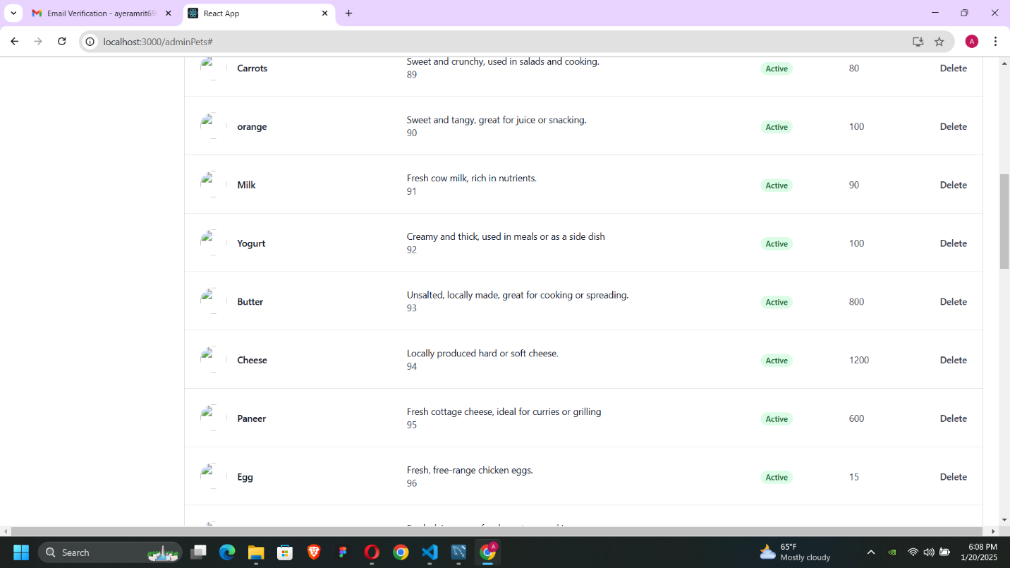

Image: Admin Panel Product View

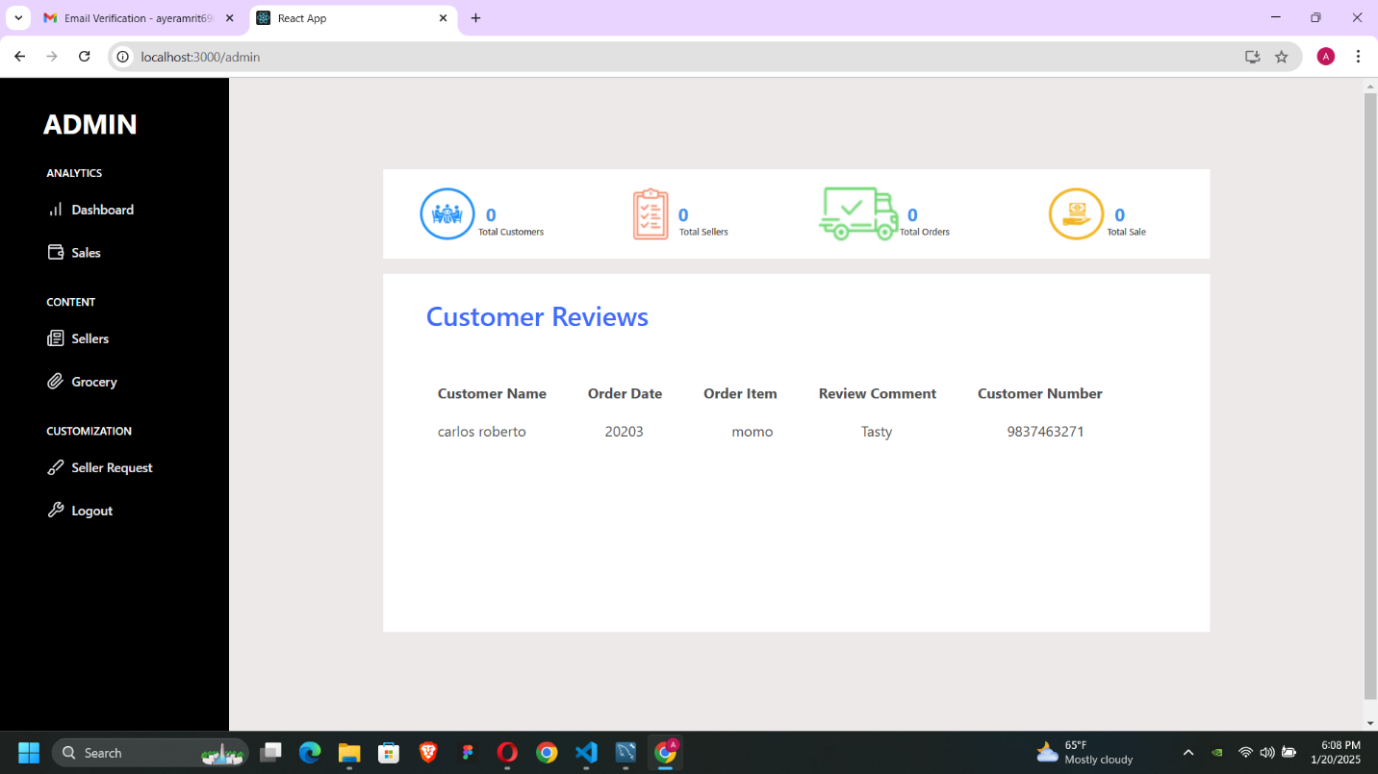

Image: Admin Dashboard

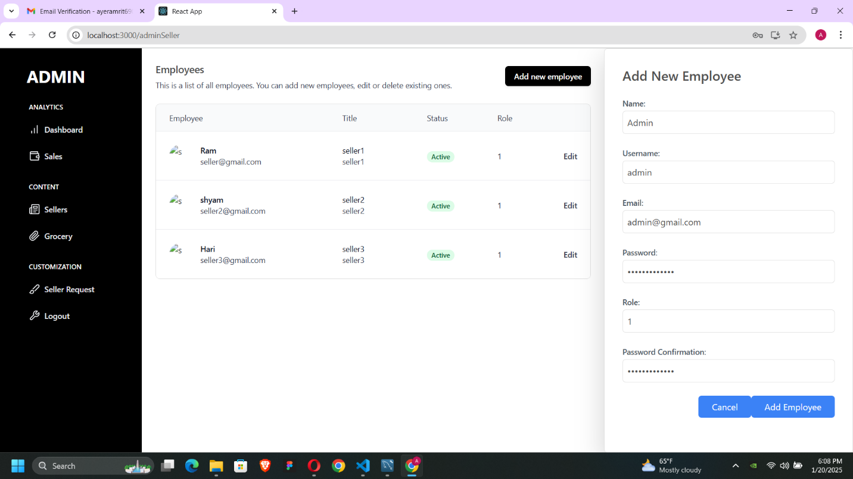

Image: seller management panel of Admin

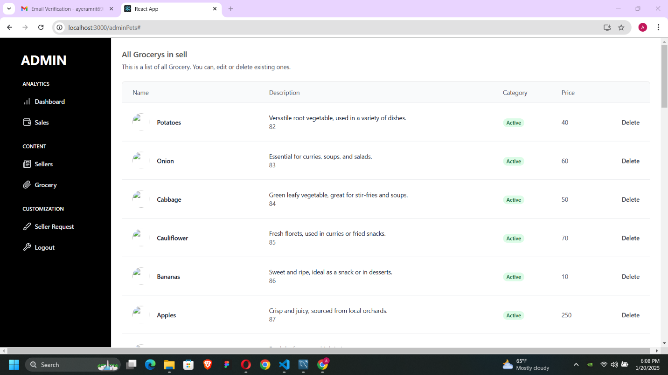

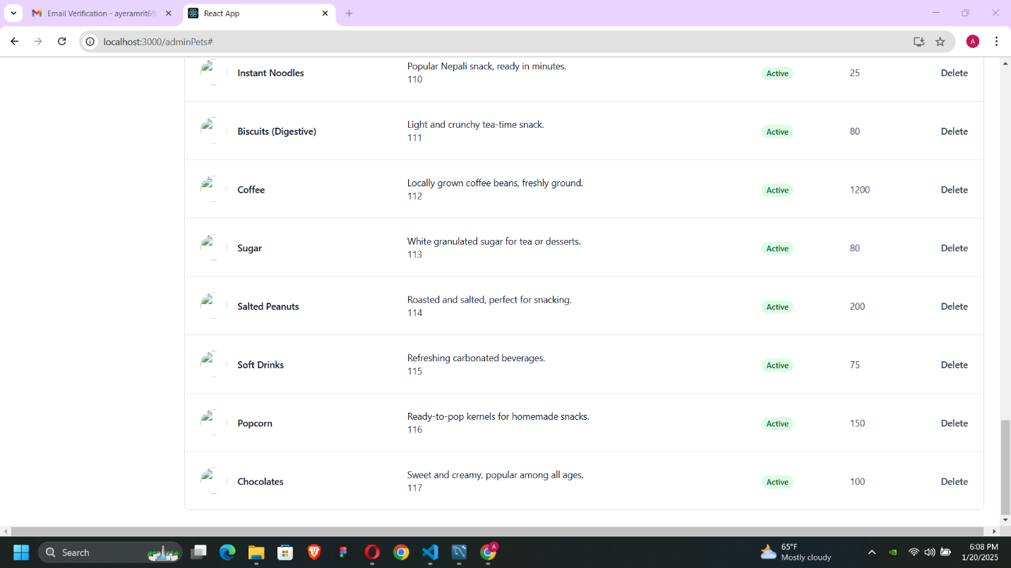

Image: Product Management portal for Admin

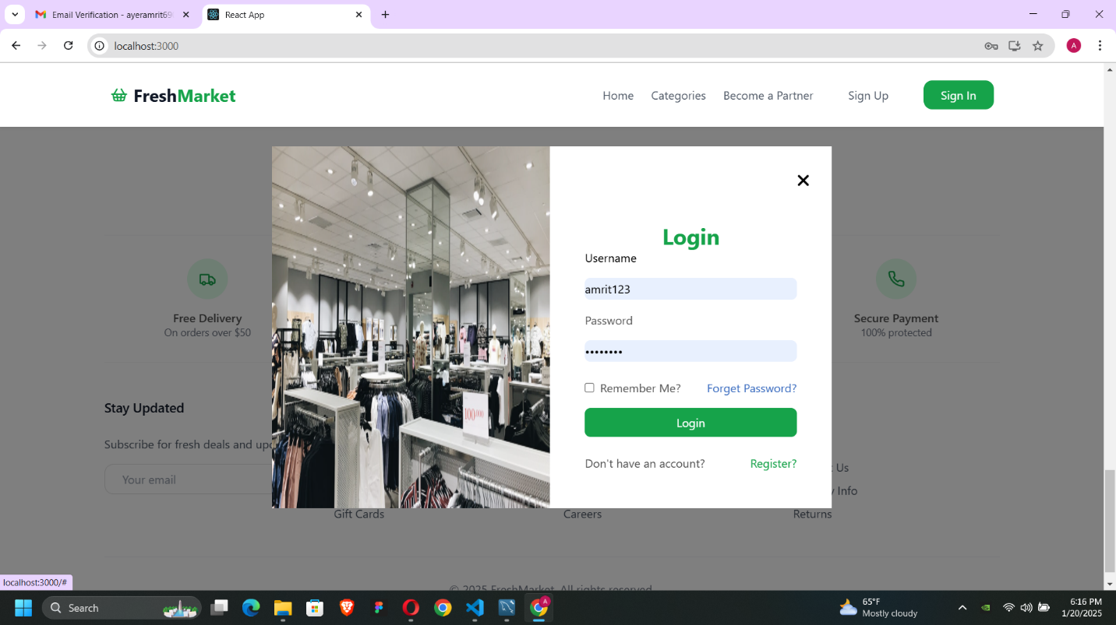

Image: Customer login panel

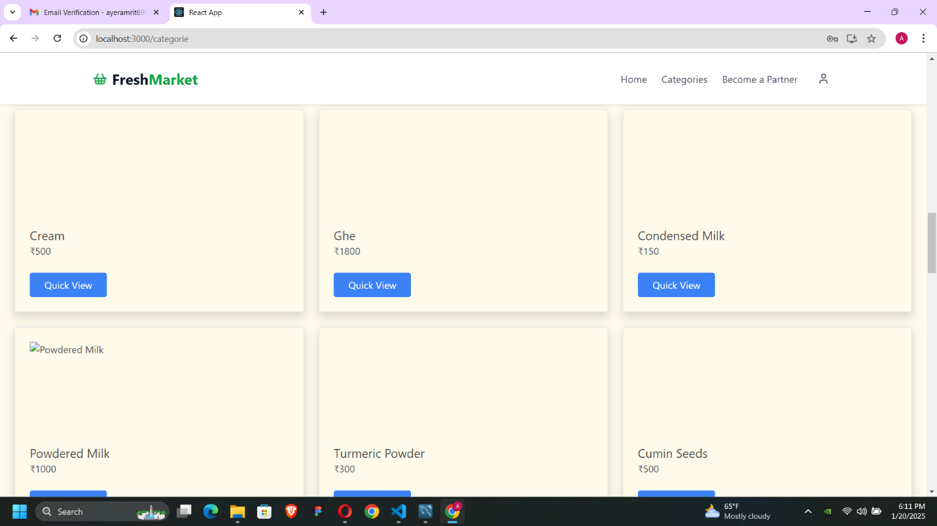

Image: Customer category viewing panel

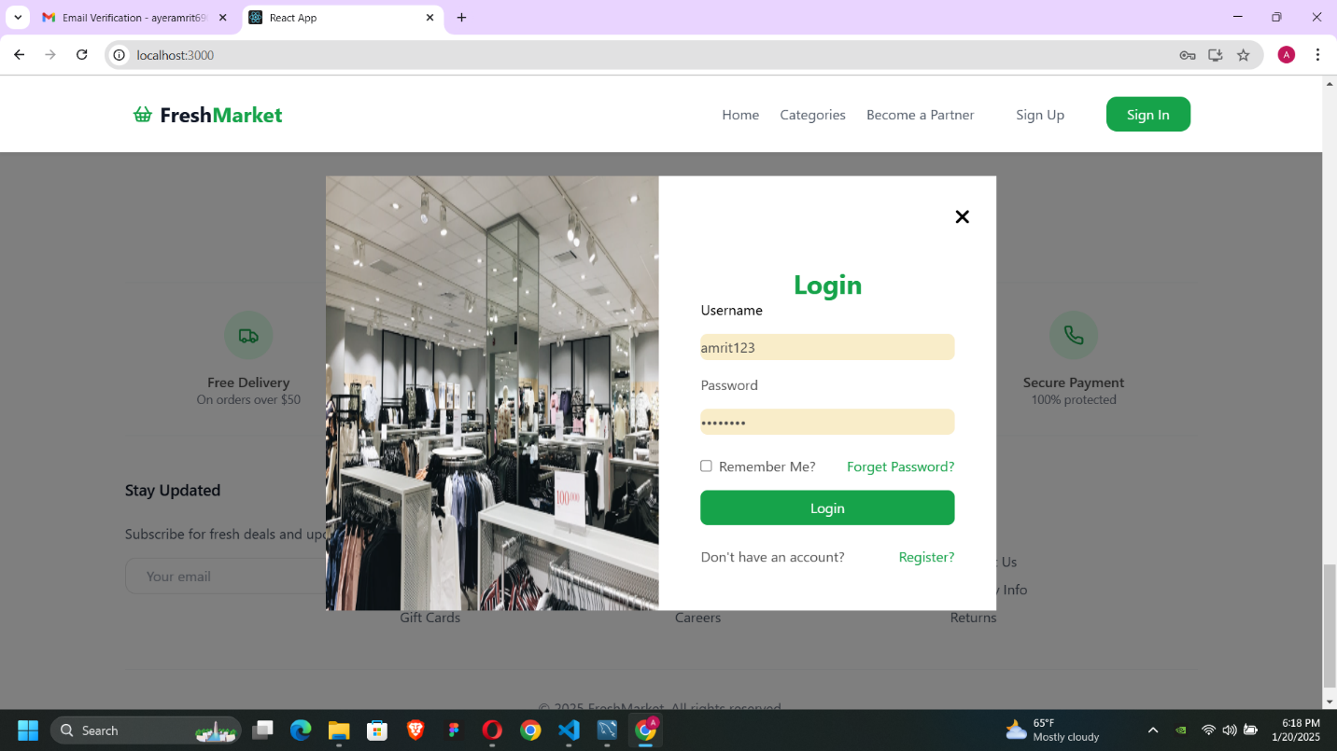

Image: Sign in page

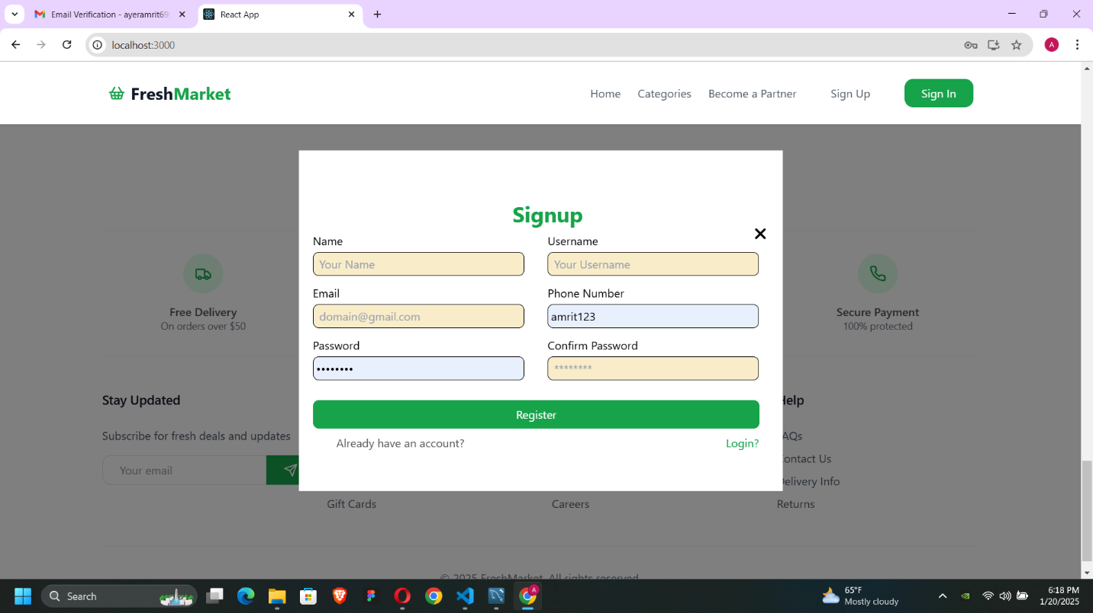

Image: Signup page

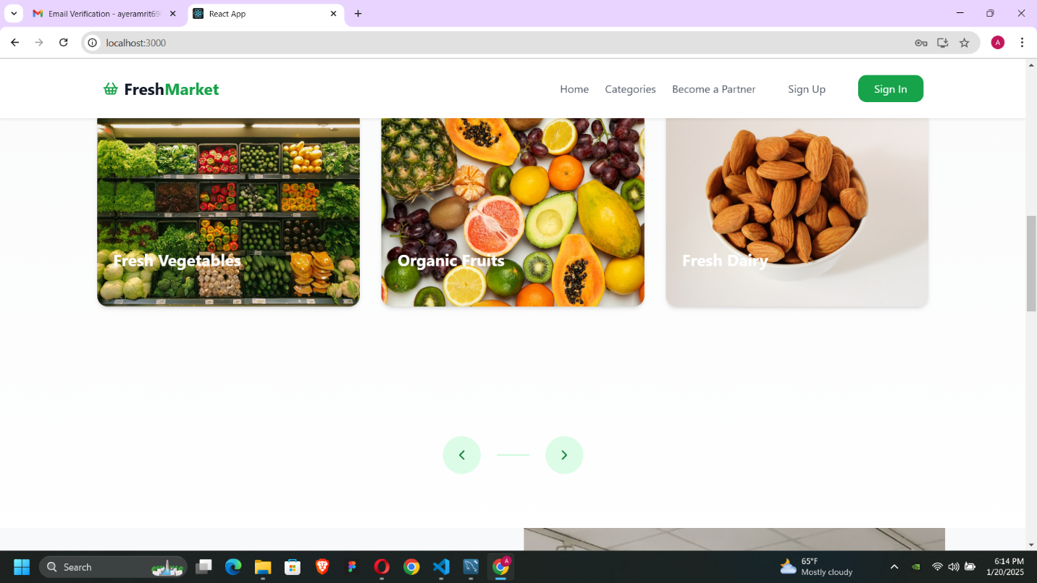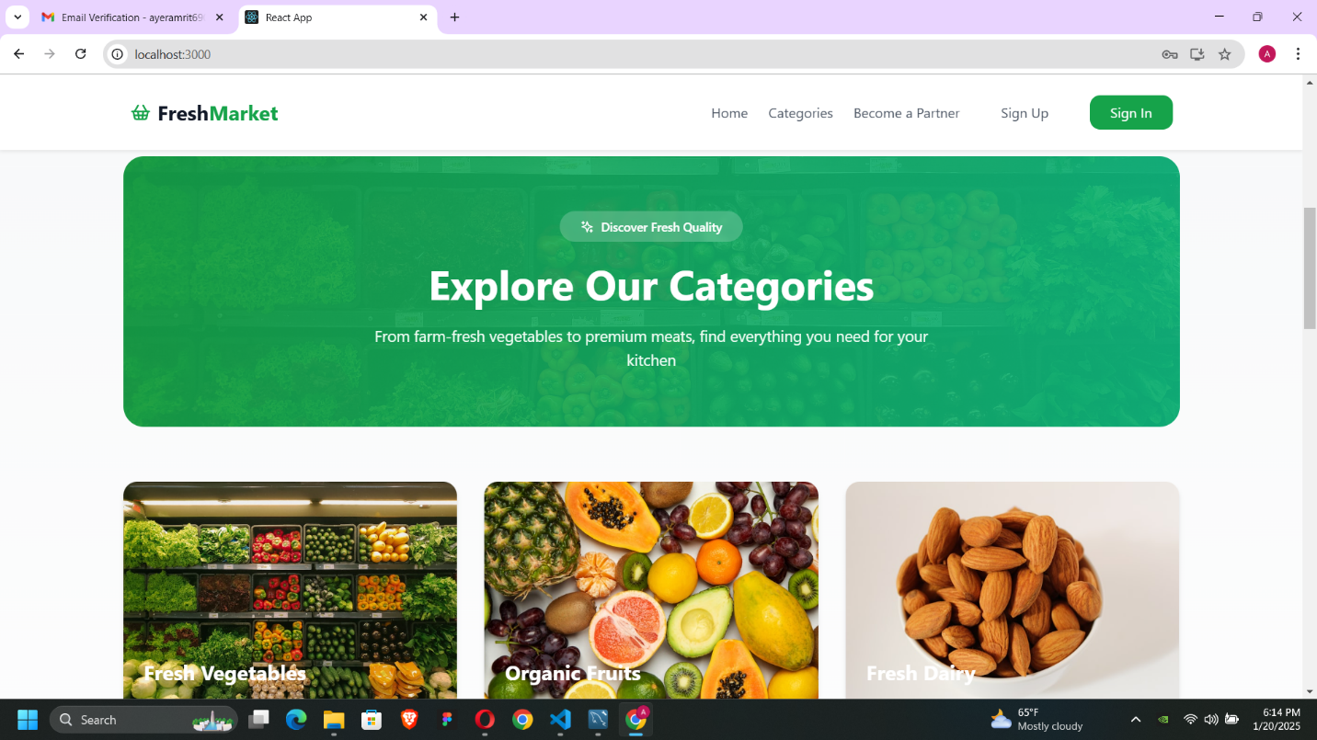

Image: Homepage

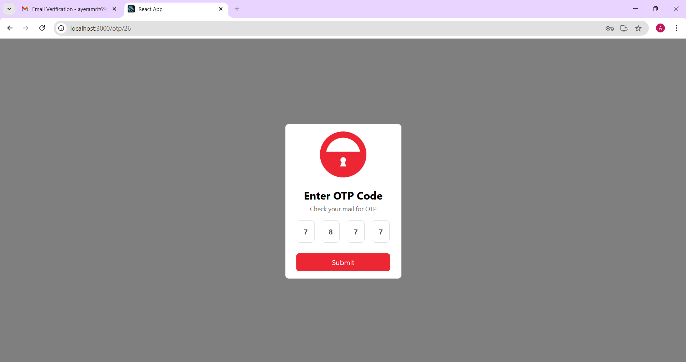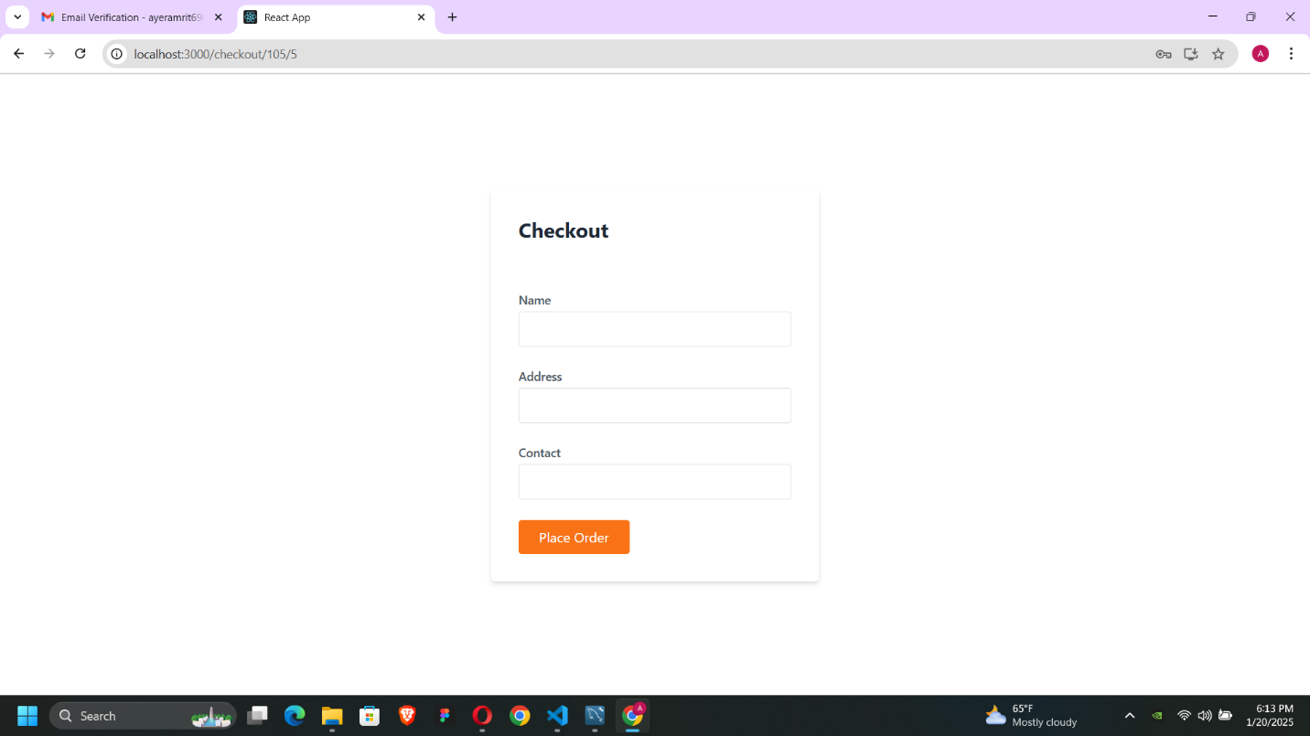

Image: Extra feature (Used SMTP for OTP generation)

Area for further Development:

1. I have wanted to integrate PayPal payment in my project.
2. Sorting and Searching and flittering

Due to the shortage of time to develop this project I couldn’t add above listed features.

GitHub link: <https://github.com/tbc-bsc-l6/component-2-dinesh69012>

YouTube Link: <https://www.youtube.com/watch?v=t9MOrAvL7QI&t=41s>